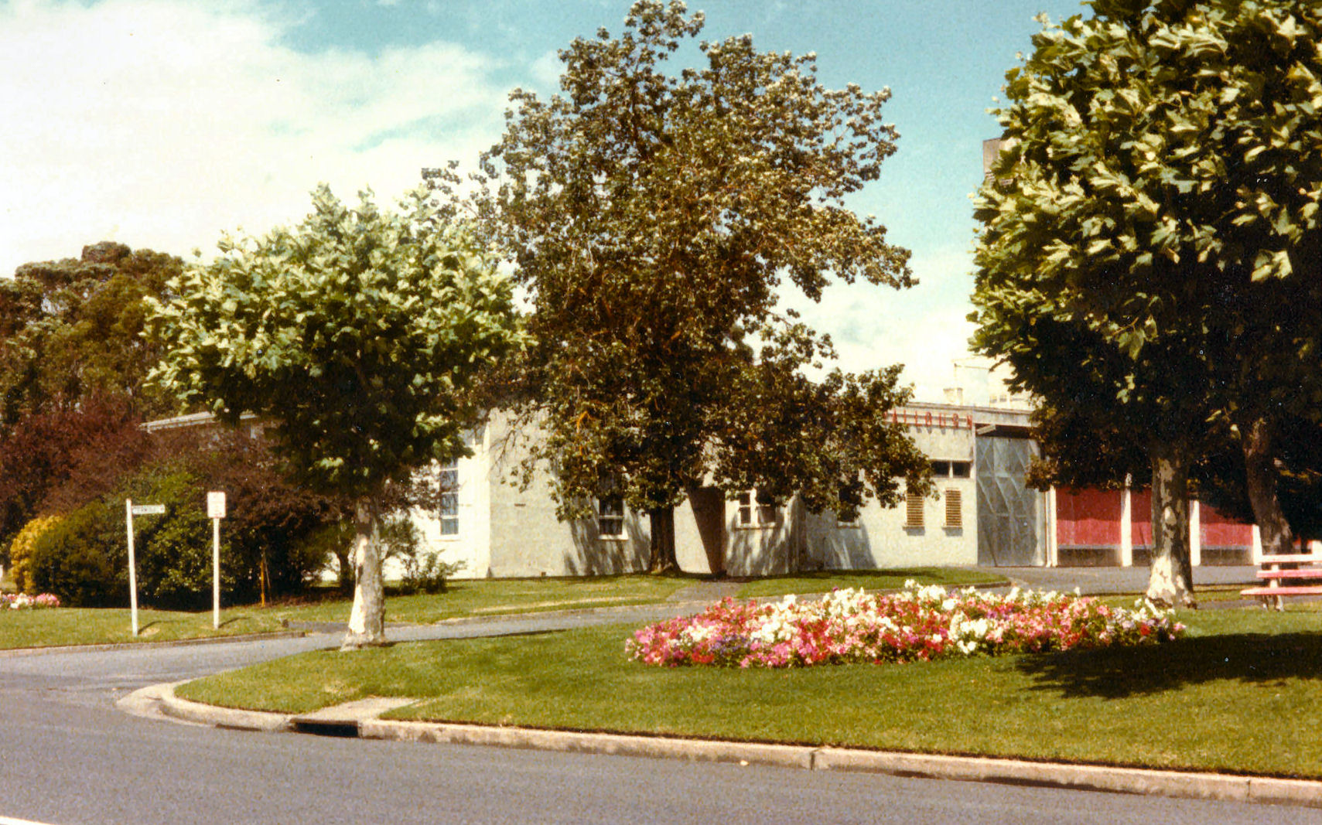
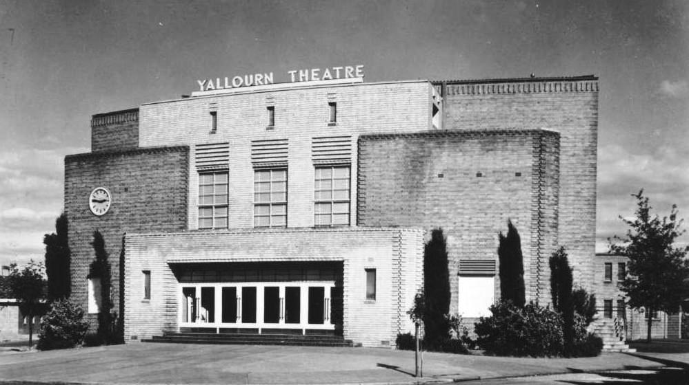
YALLOURN ASSOCIATION
P O Box 1413, FRANKSTON 3199
Phone: (03) 9775-2684 AH
Email: julie@yallourn.org
Website: www.yallourn.org

Did you live in Yallourn? If so, please partake in a special project called “Virtual Yallourn” to go on our website, where you can re-visit your old home in Yallourn to see a house plan (if available) and photos of your old house and enjoy the memories of other residents of your address and neighbours. Simply answer the following questions and return to Julie as above. Your data will be loaded and once you join in, you’ll be free to add your own memories and photos as you like. (If you didn’t live in Yallourn but know someone who did, feel free to pass on to them to complete but you can browse the site.) Let’s make this work together – get your family’s name on the map!

First Year at
Name: ...................................................... (Maiden Name: ....................................) YHS/YTS ..............

Current Contact Details - either email or phone no:..............................................................................

1st Address in Yallourn: ............................................................................................ Dates at this
address .........-.........
(eg 1953-1968)
List of family members
at this address: Parents: ..........................................................................................................................
Children: .........................................................................................................................

Can you supply a photo of this house? Yes No (Inside the house would be good too)

Can you supply a photo of your family whilst at this address? Yes No

Brief description of house (colour, wallpaper, kitchen design, carpet vs lino, floorboards, etc)...................................
...................................................................................................................................................................
...................................................................................................................................................................

Name of family who lived there before you? ...................................................................................................................................................................
Name of family who lived there after you? ...................................................................................................................................................................

Neighbours: Immediate: .....................................................................................................................
(during your time ........................................................................................................................................
at this house) Nearby: ..........................................................................................................................
........................................................................................................................................
Memories: ........................................................................................................................................
(of your time ........................................................................................................................................
at this house) ........................................................................................................................................
........................................................................................................................................
General Comments: ..................................................................................................................................
.......................................................................................................................................
Do you still have any documents from those days, eg house maintenance cards, awards, notifications from management etc? Yes No (We would be happy to copy and return promptly)

Would you be prepared to be interviewed briefly about the above? Yes No

For every additional house you lived in Yallourn, please photocopy or supply same information on a separate page. You could also draw a rough map on the reverse side of this showing neighbours etc if this is easier.

Thank you for providing the above information.

